# Overview

Upon completion of this chapter, the participant will be able to:

* List the available tracking methods in Project Server.
* Evaluate a task update from a team member before approving or rejecting the update.
* Approve a task update in PWA and publish it to the schedule.
* Describe the purpose of the status date in schedule tracking.
* Use Project Pro to track selected tasks which are on schedule or not on schedule.
* Describe the need to reschedule uncompleted work.
* Make schedule changes visible to team members through one of three alternative approaches to publishing.
* List examples of administrative time on a timesheet.
* View the details of a timesheet on the Approvals page.
* Automate approvals with a custom auto approval rule.
* Define the benefits of a delegate and act as a delegate for another resource.

# Tracking and Approval Management

After getting your schedule approved, you will be ready to begin executing your project plan, receiving updates, and responding to schedule situations that might require you to revise future tasks. Project Server provides methods to automate task updates in the schedule through the use of the Approvals page.

In this module, you will learn how to work with task updates in PWA, Project Pro, and publish those changes. You will learn about timesheet approvals and how those can give additional information related to administrative hours. You will set up an auto approval rule and learn how delegate resources can support temporary out of office situations.

## Task Updates

A task update is simply information about the progress made on a task at a specific point in time. The type of information a resource can provide in an update in PWA is determined by the tracking method implemented in the organization (see Overview of Tracking Methods).

All submitted task updates entered by resources through PWA are sent to the owner of the project (normally the project manager) on the Approvals page.

Before we show you the steps to review and accept a task update, we will discuss the various types of tracking methods. Having this information will help you learn more about the types of information you might be receiving from your team members.

### Overview of Tracking Methods

The term tracking methods refers to various ways resources can report progress on a task in PWA. Progress on a task is how much of the task work is actually completed. Resources who report task progress can submit this information to their project manager, who can apply the progress to the schedule as an update. This process saves the project manager from tracking down resources and asking for their input to the schedule.

In this section, you will learn about the three task update methods:

* Percent of work complete
* Actual work done and work remaining
* Hours of work done per period

After this discussion, we will recommend a best practice for you to follow, which will simplify the tracking process for resources.

Organizations may choose to have a separate timesheet reporting method that tracks hours worked. For more on this see Timesheets.

#### Using Percent of Work Complete

Percent of work complete is where a resource reports to the best of their ability the percentage of completeness of a task. This option allows a resource to enter any value from 0 to 100. Although some resources might be able to estimate on a very accurate level using percent complete, we recommend that you provide some structure or guidelines around this option. For example, instead of allowing resources to enter any number, you may want to suggest using 25%, 50%, 75% and 100% as recommended values. This way a resource does not have to worry about getting the value exactly correct.

Another scenario that you could use is to attach a definition to a percentage. For example, 25% could mean “getting started,” while 75% could mean “substantially complete.”

#### Using Actual Work Done and Work Remaining

Reporting task progress using actual work done and work remaining is where a resource keeps track of the total work done across all periods and records what is left in terms of work for the task. For example, if a resource did 4 hours of work during period one, and then 2 hours of work during period two, the actual work done would equal 6 hours. If the resource then does 3 more hours of work in period three, the actual work done would equal 9 hours. Since this method may require a resource to remember or review historical information, it is not useful when resources are working on numerous projects with a multitude of tasks.

Remaining work can be automatically calculated or revised by the resource as needed.

#### Using Hours of Work Done Per Period

Reporting task progress using hours of work done per period is where the resource simply reports their hours on a task that occurred only during that period. Resources do not need to worry about hours entered in past periods. This is a very popular method and you will discover in Participating as a Team Member that this option can be tied to a traditional timesheet and automatically copy information from resource timesheets into hours worked.

Remaining work can be automatically calculated or revised by the resource as needed.

Project Server can be configured in different ways based on organizational preferences. Please consult your internal Project Management Office or administrator to learn about the configuration of your environment.

#### Best Practices – Tracking Methods

Although Project Server may be configured to allow each project manager to choose their own tracking method for each project, a best practice is to enforce one tracking method for all projects. Using one method will create a uniform data entry screen for all projects on which resources are working. It will also simplify the onboarding process for new resources since they will only have to be trained in one method. In addition, reports or views across all projects will have the same level of detail of information such as percentage complete or actual hours reported.

Setting the tracking method for all projects across the organization is something that will be done by your administrator and it will automatically apply to your projects so no additional configuration will be needed.

### Reviewing a Task Update and Taking Action

The process of approving task updates involves evaluating the information received from the team member and choosing to either approve or reject the update.

The team member must choose the option to Send Status before updates will appear on the Approvals page.

How to view Task Details

* To view Task Details via the Quick Launch

1. In the Quick Launch menu, click Approvals.
2. Adjust the dividing bar to see any hidden columns.

* To view Task Details via the Task Details dialog box.

1. Click the task name.
2. Review the information in the Task Details dialog box.
3. Click Close when finished.

How to preview updates

1. In the Quick Launch menu, click Approvals.
2. Click the checkbox for the desired row.
3. On the Approvals tab, in the Actions group, click Preview Updates. Notice an additional tab in Internet Explorer has been opened with the preview of the project.
4. Close the tab in Internet Explorer to return to the Approvals page.

How to Approve a Task Update

1. In the Quick Launch menu, click Approvals.
2. Click the checkbox for the desired row.
3. On the Approvals tab, in the Actions group, click Accept.
4. In the Confirm Approval dialog box, type any desired comments and click OK.

How to Reject a Task Update

1. In the Quick Launch menu, click Approvals.
2. Click the checkbox for the desired row.
3. On the Approvals tab, in the Actions group, click Reject.
4. In the Confirm Approval dialog box, type any desired comments and click OK.

Updates that might alter other tasks or resource assignments in the schedule require that the schedule be published for these changes to be visible. Refer to the section Publishing a Schedule for these instructions.

## Tracking and Reporting with Project Professional

While team members have the ability to update their tasks in PWA, some tasks will need to be updated manually by the project manager in Project Pro. Reasons for this include tasks that are assigned to vendors or local resources who do not have access to PWA, or the project manager will have tasks assigned to himself that he would like to quickly update, such as milestones. Also, there may be some tasks that have not yet started or have uncompleted work and need to be modified. These adjustments are better suited for Project Pro.

In this section, you will learn the purpose of a status date, learn how to quickly update a project as scheduled and learn how to reschedule uncompleted work.

Be sure you have received all updates from resources on tasks before doing updates in Project Pro. This will avoid losing information from your resources that could affect your overall schedule.

It is a best practice to allow resources who have access to PWA to complete their updates in Project Server. This will save the project manager time from doing a manual update.

### What is a Status Date?

The status date is the date that represents your progress marker at a specific point in time. The status date is used a visual indicator of where your project progress should be. In other words, items to the left of the status date should be complete and items to the right of the status date should be incomplete. If that isn’t true then either your project hasn’t been properly updated (e.g. unapproved updates are available in PWA) or tasks are ahead or behind schedule and will need to be adjusted. The status date is determined by the project manager and may or may not be equal to today’s date. For example, it is possible that the project manager is on vacation and the status date is for last week.

If you change the status date, it will maintain that date. Be sure to change the status date to the next time period before receiving further task progress through PWA or before making task updates yourself that relate to the next time period.

Other names for the status date include “data date” or “time now.” The status date is used for several calculations in Project Pro including earned value calculations and options that automatically calculate a task’s completion status or automatically shifts a task based on its progress.

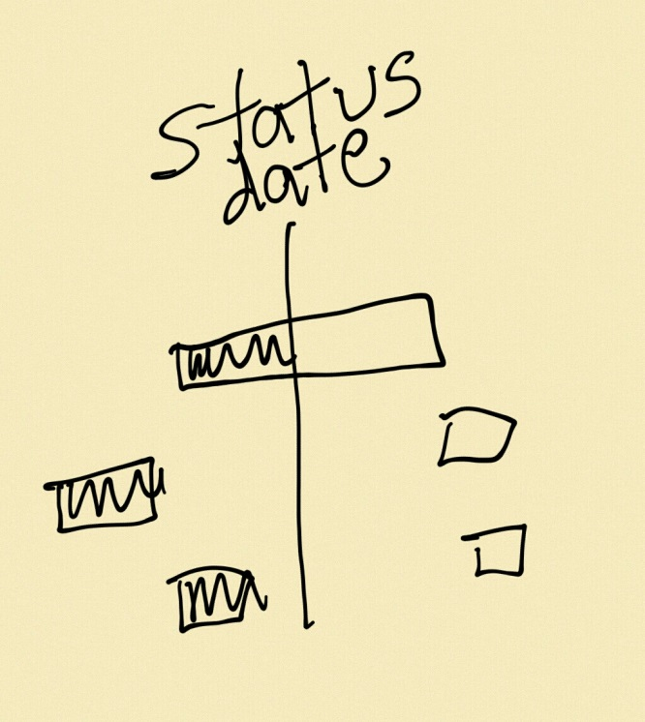

Current date

1. Tracked Project Showing Status Date and Current Date []

When printing a view that displays the status date, you can easily communicate to others when the schedule was last updated and –depending on the type of Gantt chart displayed – late tasks or early tasks can be easily identified.

By default, the status date will always equal today’s date. If that is not appropriate for your needs, it will need to be modified.

To set or change the status date:

1. The schedule you wish to publish should already be open.
2. On the Project tab, in the Status group, click the date next to Status Date.
3. Status Date [statusDate.png]
4. In the Status Date dialog box, choose or enter the desired date and click OK.

The status date line will not be visible in Gantt chart view unless you have the status date gridline configured with a line style and color.

### Updating Selected Tasks as Scheduled

When a group of tasks are proceeding normally and you want to make an update to all of them, you can choose to update selected tasks as scheduled. This process will use the status date as a guide and everything that should be completed to the left of the status date will be marked complete, while everything that should start to the right after the status date will remain uncompleted. If a task is split across the status date, only the portion that is to the left will be marked completed, the remaining portion representing the future will be left as uncompleted.

It is not necessary to set the status date before choosing the option below, since you will have an option to set the status date in the Update Project dialog box below.

To mark selected tasks as on schedule:

1. The schedule you wish to work with should already be open.
2. Select the desired tasks.
3. On the Project tab, in the Status group click, Update Project.
4. Update Selected Tasks Using the Update Project Dialog Box [updateProject.png]
5. In the Update Project dialog box, click Update work as complete through: and chose the desired status date from the dropdown menu.
6. Choose either Set 0% – 100% complete or Set 0% or 100% complete only.

* 0% – 100% complete means you would like Project Pro to mark the exact percentage of a task based on where it should be as of the status date. You could see any percentage such as 21%, 39%, etc.
* 0% or 100% complete means you would like Project Pro to mark any task at 0% or 100% only. All tasks, even if they have started will be marked at 0% unless they are finished and they will then be marked at 100%.

1. Next to For:, click Selected Tasks and click OK.

You can also choose the Mark On Track button on the Task tab in the Schedule group to quickly update a task as on schedule. This option will use the existing Status Date and apply the exact percent complete (0-100%) automatically.

### Updating Tasks Not On Schedule

Tasks that are being updated manually will not always progress according to the schedule. Tasks may start early or late or may be expected to have a shorter or longer time period to complete. In these instances, you will need to follow a process to update a task not on schedule.

1. The schedule you wish to work with should already be open.
2. Select the desired task.

Selecting only one task is recommended if you want the Update Tasks dialog box to display any available details about the task, such as current start and finish date, or current remaining duration.

1. On the Task tab in the Schedule group, click the Mark on Track dropdown and click Update Tasks.
2. Update Tasks Dialog Box []
3. Enter or change the information in one or more of these five fields of information: % Complete:, Act dur:, Remaining dur:, Actual Start:, and Actual Finish:.

You do not need to enter information in all of the fields, just enter the available information. Project Pro will calculate the remaining fields. For example, if you enter actual duration and remaining duration, Project Pro will calculate % complete and make the actual start date match the current start date. In other words, you are reporting that the task has started on time but you are adjusting the total duration for the task based on what has already occurred.

1. Click OK.
2. Repeat for additional tasks as needed.

### Rescheduling Uncompleted Work or Moving a Task

Rescheduling uncompleted work is used when scheduled work or work that should have been completed has not occurred. Rescheduling uncompleted work shifts the work to a future date. It may also be necessary to manually move a task to accommodate a schedule situation, such as a resource out for illness.

Advisicon recommends that you reschedule work manually on a task-by-task basis. If you choose to ignore uncompleted work that should have been done, it is likely that resources will not remember to go back and search out this work from a prior time period and skipping a task may alter the completion of the project.

Setting options to automatically reschedule uncompleted work is not recommended when you are using Project Pro because it may reschedule a task before all the resources working on it have reported progress.

To reschedule uncompleted work or move a task:

1. The schedule you wish to work with should already be open.
2. If needed, adjust the Status Date as discussed above.
3. Select the desired tasks.
4. On the Task tab, in Tasks group, click the Move dropdown and choose the desired option.

–

1. Task Reschedule and Move Options in Project Pro []

Moving a task will set a constraint on task but this may be required to position a task in the future. Choosing Incomplete Parts to Status Date will reschedule only the unfinished portion of the task to start after the Status Date which is useful for a task that is falling behind schedule.

## Publishing a Schedule

There are three different options for publishing a schedule following approval of a resource task update or following an update in Project Professional. We recommend you choose the method that is the most comfortable for you or the one that saves as many steps as possible based on the update that you recently completed.

To Publish a schedule following an approved task update in PWA:

1. In the Quick Launch menu, click Approvals.
2. On the Approvals tab, in the Navigate group, click the History dropdown and then click Status Updates.
3. Click the checkbox for the desired row(s).
4. On the Status Updates tab, in the Actions group, click Publish.
5. If desired, on the Status Updates tab, in the Navigate group, click Approval Center to return to the Approvals page.

We prefer using this shortcut method at Advisicon when we are already on the Approvals page since we do not have to open the project to do a Publish.

To Publish a schedule in PWA

1. In the Quick Launch menu, click Projects.
2. On the Project Center page, click on the name of the enterprise project.
3. In the Quick Launch menu for the selected project, click Schedule.
4. In the Task tab, in the Project group, click Edit and then click In Browser.
5. In the Task tab, Project group, click Publish.

To Publish a schedule in Project Pro

1. The schedule you wish to publish should already be open.
2. Click the File tab to display backstage view.
3. On the Info tab, click Publish.

## Timesheets

A timesheet is a record of hours worked on projects and may include non-project work hours in various administrative time categories such as vacation, sick, or training. Timesheets are normally a historical record of the past week, but may include administrative time recorded into the future for planned events such as vacation time.

Final timesheets created by resources through PWA are sent to the timesheet approver or resource manager on the Approvals page. This is only true if the resource does not have automatic approval of their own timesheets.

In some organizations, the project manager approves timesheets in addition to task updates. Advisicon is providing this section as a benefit to project managers who also function as timesheet approvers or resource managers.

If a resource tells you that a timesheet was submitted but you do not see it on your Approvals page, it could be because project managers of other projects have not approved all task updates and this could prevent the timesheet from being sent for approval. The feature which holds a timesheet until all task updates have been approved is controlled by your administrator.

How to view timesheet details

1. In the Quick Launch menu, click Approvals.
2. Click My Timesheet for the desired row.
3. In Internet Explorer, click Back to Approval Center (left arrow) to return to the Approvals page.

How to accept or reject a timesheet

1. In the Quick Launch menu, click **Approvals**.
2. Click the checkbox for the desired timesheet row.
3. On the Approvals tab, in the Actions group, click Accept or Reject.
4. In the Confirm Approval dialog box, type any comments and click OK.

## Auto Approval Rules

To simplify the process of seeking approval and limit the number of approvals a project manager is required to review, you have the option to set up an auto approval rule. If you are familiar with e-mail rules which locate an e-mail with a specific topic and automatically delete the message or automatically take another action such as move the message into a folder, the general concept is the same in Project Server; a rule is automating a repetitive action. Auto approval rules can be tailored for a specific project, specific resource, or specific type of task. Rules can also run and publish the schedule automatically or be run manually.

Auto approval rules clean up the approvals page for you. To view the approvals that were completed through a rule, you need to view the history.

To set up an auto approval rule:

1. In the Quick Launch menu, click Approvals.
2. On the Approvals tab, in the Navigate group, click Manage Rules.
3. Accessing Auto Approval Rules []
4. On the Rules tab, in the Rule group, click New.
5. On the Edit/Create Rule page:
6. In the Name: box, type a name for the rule.
7. In the Description and Comments for Team Members: box, type a description if desired.
8. In the Automatic updates section you have two choices.

Decide if you want the rule to run and/or publish without your intervention.

1. In the Request Types section, you have four choices.

Decide which types of task updates this rule should apply to.

1. In the Projects section, you need to choose one option.

Decide if you want the rule to apply to specific projects or all projects.

1. In the Resources section, you need to choose one option.

Decide if you want the rule to apply to specific resources or all resources.

1. Click Save to accept all changes.

## Delegation

Resources can become unavailable for any number of reasons. If you know that a resource will be permanently unavailable, you should reassign their work to another person who will take ownership. However, a resource may become unavailable for a short period of time and then will be able to resume their work. In an instance such as illness, a personal holiday, or a short leave of advance, the efficient way to reassign work in PWA is to create a delegate who will act as a temporary substitute for the absent resources.

Warning – Delegation only works in PWA, it does not work in Project Pro.

### Managing Delegates

A person who temporarily manages work for another peer is called a delegate. Advisicon recommends that you select delegates who perform the same job role as the person who will be temporarily unavailable. This will make the transition very smooth during the delegation period and should prevent accidental security breaches or unexpected changes which might occur if a delegate is selected from a different job role.

Your Project Server administrator can choose a delegate for any user in the organization. Project managers are only allowed to create a delegate for themselves.

Use the expiration date for the delegate so you don’t have to remember to disable it a future date.

To create a delegate:

1. In the Quick Launch menu, click Server Settings.
2. Under Personal Settings, click Manage Delegates.

Manage Delegates Option []

1. XXX

### Acting as a Delegate

After being assigned as a delegate, the delegate will perform two independent roles in PWA: the delegate’s own job functions in PWA and the person’s job functions for whom they are acting as a delegate. This may include updates to tasks, timesheets, approvals, and schedules.

Throughout the delegate session, you are provided a notice in the status line that you are in a delegate sessions. Failure to stop this session incorrectly attributes your job functions to the person you are acting as a delegate for.

To act as a delegate:

1. In the Quick Launch menu, click Server Settings.
2. Under Personal Settings, click Act as a Delegate.

Act as a Delegate Option []

1. Click the name of the resource you need to perform delegate duties for and then on the Delegations tab, in the Delegate group, click Start Delegate Session.

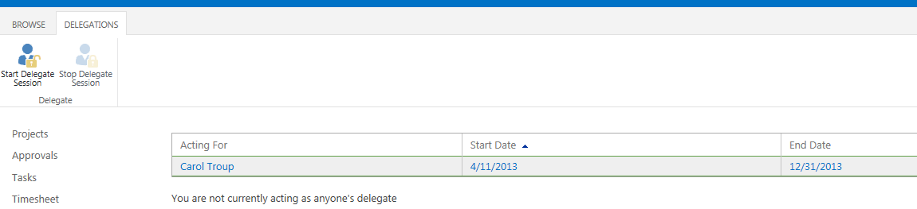

Starting a Delegation Session []

To stop acting as a delegate

1. In the status line, notice the option Click here to manage your delegation.
2. Click the hyperlinked word here to return to the Act as a Delegate page.
3. On the Delegations tab, in the Delegate group, click Stop Delegate Session.

# Key Points to Remember

* Receive updates from team members in PWA is the most efficient way to track and update the schedule.
* The Approvals page lists Status Updates and Timesheet pending approvals from team members.
* Update or track progress on tasks in Project Pro when a local resource does not have access to PWA to provide updates or as a shortcut for the project manager to update his own tasks.
* Use Project Professional and available features to reschedule or move tasks that are not proceeding according to schedule.
* Publishing a schedule through the History on the Approvals page is a fast way to publish without opening the schedule.
* Publishing a schedule is required following task updates or approvals so changes to the schedule are applied and visible to team members.
* Timesheets may be auto approved or be sent to a timesheet approver, such as a resource manager, or project manager.
* Timesheets represent hours worked for an entire week and may include administrative time such as sick, training, and vacation time.
* Set up auto approval rules to automate repetitive tasks for the project manager.
* Delegation is useful way to have someone fill in for a resource who will be out of the office for a temporary period of time.